A university has initiated a project to develop an Online Student Portal where students can view grades, register for courses, and pay fees. The project manager decided to use MS Project for scheduling, hold weekly review meetings every Monday, and report any delays greater than three days to stakeholders. The project was broken down into the following activities: gathering requirements (5 days), database design (4 days), UI design (3 days), backend development (10 days), frontend development (7 days), integration (4 days), testing (5 days), and deployment (2 days). These activities had clear dependencies: requirements had to be completed before both database design and UI design could begin; backend development depended on database design; frontend development depended on UI design; integration required both backend and frontend to be finished; testing could only start after integration; and deployment could only be done after testing. Based on these estimates and dependencies, the total project duration was planned to be 30 days. However, during execution, frontend development was delayed by 2 extra days, creating a risk of pushing integration and testing further back. To manage this, the project manager applied schedule control by allowing the backend team to begin partial integration earlier while frontend work was still ongoing. This adjustment helped keep the project on track and ensured that testing and deployment could still be completed on time.

List all the activities involved in the project.
Arrange the activities in their correct sequence based on dependencies.
Prepare a table showing activities, durations, and dependencies and timeline .
Draw a Gantt chart (or timeline) for the planned 30-day schedule.
Identify what problem occurred during execution and what control action was taken.
Explain how this control action helped the project stay on schedule.

Model Answer Key

Activities:

Gathering requirements
Database design
UI design
Backend development
Frontend development
Integration
Testing

DeploymentSequence:
Gathering requirements → then both Database design and UI design (in parallel).
Database design → Backend development.
UI design → Frontend development.
Backend development + Frontend development → Integration.
Integration → Testing → Deployment.
Activity | Duration (days) | Depends on | Planned Start (day) | Planned End (day) | Timeline calculation
Gathering requirements | 5 | — | 1 | 5 | Start = 1; End = 1+5−1 = 5
Database design | 4 | Requirements | 6 | 9 | Start = Req End+1 = 5+1 = 6; End = 6+4−1 = 9
UI design | 3 | Requirements | 6 | 8 | Start = 6; End = 6+3−1 = 8
Backend development | 10 | Database design | 10 | 19 | Start = DB End+1 = 9+1 = 10; End = 10+10−1 = 19
Frontend development | 7 | UI design | 9 | 15 | Start = UI End+1 = 8+1 = 9; End = 9+7−1 = 15
Integration | 4 | Backend + Frontend | 20 | 23 | Start = max(Backend End, Frontend End)+1 = max(19,15)+1 = 20; End = 20+4−1 = 23
Testing | 5 | Integration | 24 | 28 | Start = 23+1 = 24; End = 24+5−1 = 28
Deployment | 2 | Testing | 29 | 30 | Start = 28+1 = 29; End = 29+2−1 = 30

Planned Gantt chart → Students should produce something similar to the one we created (30-day total).
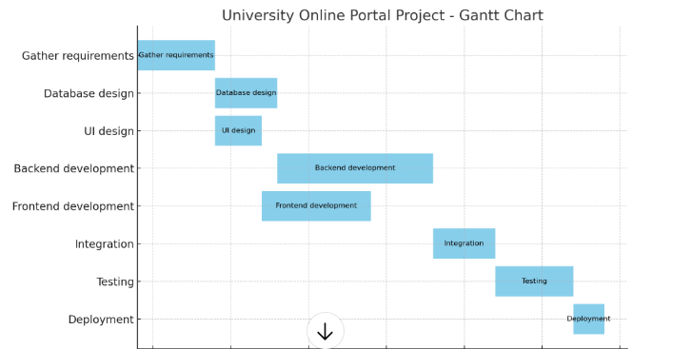

Problem → Frontend development was delayed by 2 extra days (so it ran 9 → 17 instead of 9 → 15).This created a risk that Integration (which needs final frontend modules) and downstream Testing/Deployment could be pushed back.
Note: with the original durations Backend finished on Day 19 and Frontend (with +2 days) would finish Day 17 — technically Integration could still start after Day 19 unaffected. However, in many real projects integration tasks need specific frontend components (or end-to-end tests) that, if delayed in any part of the frontend, create a perceived or practical risk to integration start date. So the team treated the frontend slip as a real schedule risk.

Control action → The project manager allowed the backend team to begin partial integration earlier while the frontend team completed remaining work.

Practically this means: backend modules were integrated with the database and with frontend stubs/mocks or the completed frontend components; backend-to-DB integration, API stabilization, and module-level integration and tests were done early (parallel to finishing frontend). Only the final glue work waited for last frontend pieces.

Planned: Frontend end = Day 15 → Integration start = Day 20
Actual: Frontend delayed +2 → Frontend end = Day 17

Manager action: Backend performed partial integration on Days 16–19 (integrating backend modules, DB, and using frontend stubs). Full integration (final glue) still scheduled Day 20–23.

Testing/Deployment: kept at Day 24–30 as planned. So the effective schedule looked like:

Backend full work: Day10–19 (as planned)
Partial integration (backend + DB + stubs): Day16–19 (overlap with frontend finishing)
Full integration (final) : Day20–23 (as planned)
Testing : Day24–28
Deployment : Day29–30

When integration is on the critical path, prepare integration tasks that can be done incrementally (module by module) so small frontend slips don’t block the whole activity.

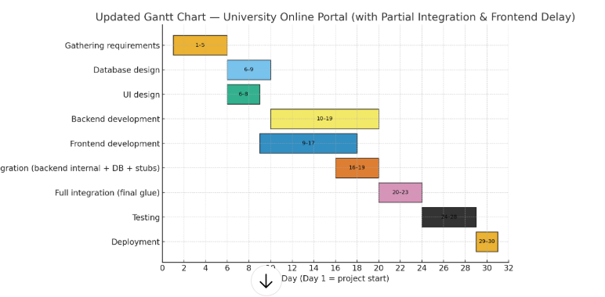
A university has initiated a project to develop an Online Learning Platform where students can access lectures, submit assignments, and track their progress. The project manager planned that all project costs would be tracked in MS Excel, financial reports would be reviewed weekly, and any cost overrun greater than 10% would require sponsor approval. The estimated costs for activities were: requirements gathering $1,500, database design $2,000, UI/UX design $2,500, backend development $7,000, frontend development $5,000, integration and testing $3,000, and deployment with hosting setup $1,500. The total estimated cost came to $22,500, and with an additional management reserve of $2,500, the final approved budget was set at $25,000. During execution, by the midpoint of the project, $12,000 was planned to be spent, but the actual cost was $14,000, mainly due to unexpected revisions in the UI/UX design. To control costs, the project manager reduced unnecessary overtime, negotiated lower hosting expenses, and used part of the management reserve to handle the overrun.

Identify how the project manager applied Plan Cost Management in this case.

Decided the method and rules for cost control: track costs in MS Excel, prepare weekly financial reports, and review them in team meetings.
Set an approval rule: any cost overrun > 10% must be approved by the sponsor.
Defined invoice processing cadence (monthly) and a management reserve policy (used later).
These decisions document how costs will be planned, tracked, reported, and controlled.

List the estimated costs for each activity and calculate the total.

Activity | Estimated Cost
Requirements gathering | $1,500
Database design | $2,000
UI/UX design | $2,500
Backend development | $7,000
Frontend development | $5,000
Integration & testing | $3,000
Deployment & hosting setup | $1,500
Total (sum) | $22,500

Explain how the budget (cost baseline) of $25,000 was determined.

The project manager aggregated the activity estimates to form the cost baseline: $22,500 (sum of estimates).

Added a management reserve (contingency) of $2,500 to cover identified/unknown risks.
Final approved budget = $22,500 + $2,500 = $25,000.
The $25,000 is the authorized spending limit and the baseline used for monitoring actuals.

Analyze the cost overrun during execution and identify the control actions taken by the project manager.

By midpoint: Planned spending = $12,000, Actual spending = $14,000 → $2,000 overrun. Root cause: extra/unexpected UI/UX revisions drove up design costs.

Control actions taken
Reduced unnecessary developer overtime (cut variable labor costs).
Negotiated lower hosting costs (reduced recurring/operational expense).
Used part of the management reserve ($2,500) to cover the overrun without breaching the approved budget.

Result
These actions contained the overrun and kept the project within the $25,000 authorized budget.

